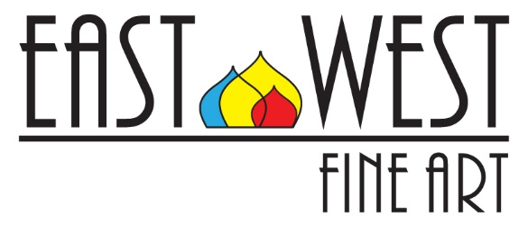

ART CONSIGNMENT AGREEMENT

The Artist (name, address, telephone number, e-mail):____________________________

_____________________________________________________________________

The Gallery (name, address, telephone number, e-mail):
East West Fine Art
9115 Strada Place, #5130. Naples, FL 34108; 239 821 9459
info@eastwestfineart.com

hereby enter into the following agreement:

1. AGENCY; PURPOSES. The Artist appoints the Gallery as agent for the works of art consigned under this agreement, for the purposes of exhibition and sale. The Gallery shall not permit the works of art to be used for any other purposes without the written consent of the artist.

2. CONSIGNMENT. The Artist hereby consigns to the Gallery, and the Gallery accepts on consignment, those works of art listed on the attached inventory sheet which is made a part of this agreement.

3. WARRANTY. The Artist hereby warrants that he created the Work of Art and possesses the unencumbered title to the work of art, and that his descriptions are true and accurate.

4. DURATION OF CONSIGNMENT. The Artist and the Gallery agree that the initial term of consignment for the work of art is to be ____12______ months, and that the Artist does not intend to request the return of the works of art before the end of this term. Thereafter, consignment shall continue until the Artist requests return of any or all of the works of art or the Gallery requests that the Artist take back any or all of the works of art with which request the other party shall comply promptly.

5. TRANSPORTATION RESPONSIBILITIES. Packing and shipping charges, insurance cost, other handling expenses, and risk of loss or damage incurred in the transportation of the works of art to and from the Gallery, shall be the financial responsibility of the Artist. Gallery arranges the shipment of unsold art to the Artist.

6. FIDUCIARY RESPONSIBILITIES. Title to each of the works of art remains in the Artist until the Artist has been paid the full amount owing him for the works of art; title then passes directly to the Purchaser.

7. PRICING; GALLERY'S COMMISSION; TERMS OF PAYMENT.
The prices (wholesale) of the artworks consigned are listed in the Consignment Agreement. The Gallery agrees to pay 100% of the wholesale price. The change of the wholesale price must be agreed by the Gallery and the Artist.

Payment to the Artist shall be made by the Gallery within 14 days after the date of sale of any of the works of art.

8. REPRODUCTION. The Artist reserves all rights to the reproduction of the works of art except as noted in writing to the contrary. The Gallery may arrange to have the work of art photographed to publicize and promote the work of art through means to be agreed to by both parties. In every instance of promotional use, the Artist shall be acknowledged as the creator and the copyright owner of the work of art.

10. TERMINATION OF AGREEMENT. Notwithstanding any other provisions of this Agreement, this Agreement may be terminated with the agreement between the Gallery, and the Artist.

11. EXCLUSIVITY AGREEMENT. Artist agrees not to sell his/her artwork through another vendor or personally within 50 mile radius of physical location of the Gallery.

12. PROCEDURES FOR MODIFICATION. Amendments to this Agreement must be signed by both Artist and Gallery and attached to this Agreement.

This the _____ day of ______________, 20___.

ARTIST:

________________________________
Name of Artist

________________________________
Signature

GALLERY:

East West Fine Art
Leeza Arkhangelskaya
Co-owner

________________________________
Signature

Artist | Name of Artwork | Dimensions / Medium | Wholesale Price

